University Library

RMIT Research Repository accessibility review

September 2021

About this review
The Research Repository is a collection of peer-reviewed research outputs and publications produced by RMIT University researchers, including Higher Degree by Research candidates. It runs on the Esploro platform by ExLibris. Esploro has two components: Researcher Profiles and the Research Portal. The Research Portal is a showcase and a search interface for researchers and research outputs.
This review focussed on the Research Portal search process.

Pages reviewed:
- Landing page
- Search results page
- Full record page

Reviewers:
Ronny Andrade Parra, Digital Accessibility Specialist (ronny.andrade.parra@rmit.edu.au)
Iza Bartosiewicz, Library Web Coordinator (iza.bartosiewicz@rmit.edu.au)

Review methods:
We’ve manually tested the three pages using
- Windows with JAWS and NVDA
- MacOS with VoiceOver
- Keyboard
We’ve used these automated tools:
- WAVE Web Accessibility Evaluation Tool
- Landmarks extension

Please note, this is not a comprehensive evaluation of this application. We recommend a thorough evaluation that will consider WCAG compliance as well as the usability of the interface and functionality to its diverse users.

Global navigation
Where: All pages
Priority: High

‘Skip to content’ link is missing, which means keyboard users won’t be able to bypass the navigation options
WCAG reference: 2.4.1 Bypass Blocks (level A)
Recommendation: Add a "Skip to content” anchor link at the beginning of each page. This link may be visually hidden but become visible when receiving focus. Make sure this is the first link a keyboard user encounters when accessing the page (i.e. the link is placed before the RMIT logo link).

Search function
Where: All pages
Priority: High
There are multiple issues with the search option provided in the banner.
The search box doesn’t get expanded on mouseover, but it does on keyboard focus. The search box should not extend on keyboard focus.
Once the search text box has been expanded, it cannot be collapsed with the Escape key. If the search text box cannot be collapsed, keyboard users are unable to access the “Library home page”, “About the research repository”, and “New search” links.
Tabbing out of the search box bypasses the menu options. This means the menu options will be inaccessible to keyboard users, unless they back tab.
The top search box doesn’t indicate what it will search for. If there are two search boxes on a single page, it is important to label them so that it is clear both visually and programmatically, what is being searched.
In the main search box, when using arrow keys to navigate through the search limit options (without hitting enter), the NVDA screen reader repeats the labels twice.
WCAG references:
- 2.1.1 Keyboard (Level A)
- 2.1.2 No Keyboard Trap (level A)
- 4.1.2 Role, Name, Value (level A)
Recommendation: Disable the top banner search function. There is already a search box on that page, plus there’s a New Search link in the header, so this search box is unnecessary.
Ensure that the top menu is accessible to keyboard users.

Top menu
Where: All pages
Priority: Low
Top menu lacks semantic structure. W3C recommends using semantic markup, such as a list, to convey the menu structure.
The three menu options are not market up as a list. When navigating with keyboard, there is a symbol (looks like a full stop) between the links “Library home page”, “About the research repository”, and “New search”. It is vocalised by the screen reader and is confusing.
W3C reference: Menu structure

Downloads by country interactive map
Where: Landing page

Duplication adds unnecessary complexity
Priority: Medium
This interactive map presents the same information in two different formats. One is a chart, which is operable with the keyboard or a mouse. The second one presents the figures in a data table and can only be operated with the mouse.
None of these options are fully accessible:

- Using the mouse to interact with the chart requires precision that would be difficult to achieve for some users. Keyboard users can tab through the options.
- NVDA users will hear ‘clickable graphic’ when tabbing through the options.
- The data table allows mouse users to interact with the map, but the interactivity is not visually obvious. This option is also inaccessible to keyboard users.
- There is a table that contains the countries, number of downloads and corresponding percentages. This table is a good way to present content to screen reader users. However, this information is repeated as a screen reader user navigates through the rest of the page.
- In the table, the totals for Australia, United States and Singapore are not read correctly.

Recommendation: Make the div “advanced-pie-legend-wrapper" hidden to screen reader users with aria-hidden="true". This way you will avoid duplication.

Heading below the content
Priority: Low
The screen magnifier users and mobile users will see the numbers before the heading (Image 1). This is not a critical issue but placing the heading below its content should be avoided whether it is done visually using CSS or in a source code.
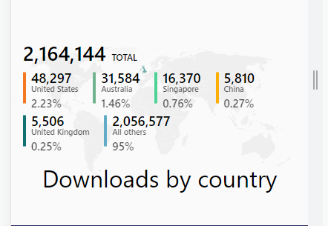
Image 1: Screenshot showing the positioning of the heading below the content as displayed on a mobile screen.

‘Top Ten’ slides navigation
Where: Landing page
Priority: Medium
On the ‘Top ten’ section, the currently active slide needs to be communicated to the users. The grey dots that indicate individual slides are labelled ‘Go to slide 1’, ‘Go to slide 2’, and so on. However, a screen reader user is not aware of what slide they’re in.
The ‘more’ button on the individual publications on each slide is not designed to work well with keyboard only. When activated with the keyboard, either nothing happens, or the grey background of the slideshow expands without showing more text.
For screen reader users, the ‘more’ button is found after the entire content of the individual publication has been read, thus making it pointless.
The ‘more’ button does not have an adequate label. A screen reader user navigating from button to button will hear ‘more’ three times without any context. This fails success criterion 4.1.2 Name, Role, Value (level A).
Screen reader users listen to articles that are not visible in the current slide. Information presented to screen reader users should match the information presented to users, who can use their sight to explore content.
Once a keyboard user selects one of the filter options (‘Recently added’, ‘Most downloaded’, or ‘Most viewed’), the next tab lands on the ‘next’ arrow instead of the first record. The subsequent tabs go through the pagination bullets before finally landing on the first record. This means that keyboard users will need to tab ten times to reach the ‘more’ option to read a full description of the first record.
WCAG references:
- 2.1.1 Keyboard (Level A)
- 4.1.2 Role, Name, Value (level A)

Navigating and filtering search results
Where: Search results page
Priority: High
The page content is not presented in a logical order for keyboard users. Keyboard users must navigate through every single filter (on the left side of the page) before they can get into the content if they are exploring the page sequentially. This results in a tedious user experience for keyboard users and fails WCAG success criteria 2.4.1 Bypass Blocks (level A) and 2.4.3 Focus Order (level A). This could be fixed with the proper use of regions.
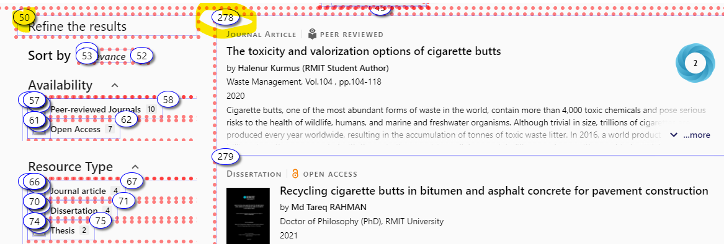
Image 2: A screenshot showing tab order on the search results page
The ‘more’ button on each individual result entry has the same problem as the ‘more’ button detailed in the Top Ten’ slides section: it is graphically oriented. Programmatically, it is located at the end of each abstract, so when a screen reader user hears it, the button is irrelevant. The ‘more’ button does not have an adequate label.
Each filter option is presented as a region. This is not an appropriate way of using regions.
On each filter option there are unlabelled checkboxes and an incorrectly applied ARIA roles, where text elements have been given the role of buttons. For example, for the filter ‘Journal article’, a screen reader user would hear something like “Checkbox not checked” followed by “Journal article button.” The text element should not have a role of button and the checkbox should be “labelled by” the text element. The current way in which filters are programmed does not meet users’ mental models of buttons and checkboxes. Using form markup would be a more semantically appropriate option here.
On each filter there is a hidden button to exclude a particular filter. It appears on a tab focus and on mouse hover, but it is not available in mobile view. The tooltip on the icon repeats the label of the checkbox, but it doesn’t clarify what will happen when this option is selected. The icon on its own may not provide adequate visual clue as to the function of this button.
WCAG references:
- 2.4.1 Bypass Blocks (level A)
- 2.4.3 Focus Order (level A)

Open Access document viewer
Where: Full record page
Priority: High
The viewer used to display Open Access articles is not accessible to screen reader users. This dialogue has the options to “close” or “download.” The download button does not seem to download the PDF to the user’s computer. The PDF viewer that appears in the pop up is not accessible.
The user should be allowed to download the document and open it with their preferred assistive technology. Currently, the process to download a PDF is cumbersome.
WCAG reference: 2.1.1 Keyboard (Level A)

Heading structure
Where: All pages
Priority: Low

Best practice for structuring web content is to have a single heading level 1, which corresponds to the page title, followed by correctly nested sub-headings. The landing page has three H1 headings and only the first one is appropriate for the page content.

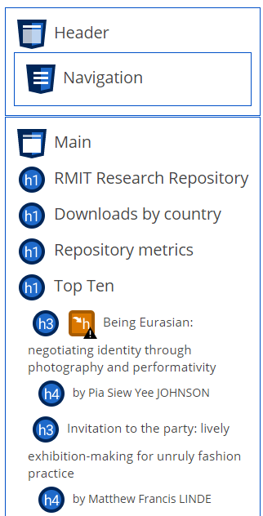
Image 4: Heading structure of the landing page as presented by the WAVE tool.
On the search results page, there is a hidden H1, which says ‘Profiles search’. Then there are two H2: ‘Search results’ (hidden) and ‘Refine the results’ (visible). While the hidden headings are meant to help screen reader users understand the page structure, the ‘Profiles search’ is not meaningful and the list of search results appear under the ‘Refine the results’ heading, instead of the hidden ‘Search results’ heading.
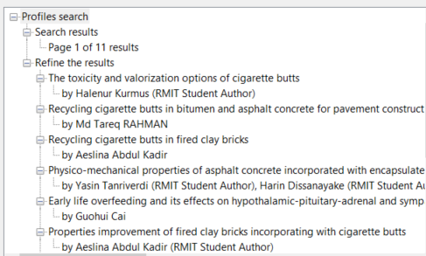
Figure 5: Heading structure of a sample search results page.
WCAG references:
- Using h1-h6 to identify headings
- 1.3.1 Info and Relationships (Level A)

Recommendation: Make sure heading structure reflects the logical order of content on all pages, including hidden headings.

